
FIN2010 | Financial Management
Lecture 1: What is Finance?




What is Finance?
     | Financial Industry

Investors who have money

Borrowers who need money

 | Lecture 1: What is Finance | 2


Agenda
•Investors and borrowers
•Does finance create value?
•Financial institutions
•About this course
 | Lecture 1: What is Finance | 3

Who are the Borrowers?
Central Gov. |  |  | Local Gov. | GDP
•Government |  |  |  | GDP
•Government | US
China
Equity |  |  | Bond
•Business
  US
China
Home Loan |  |  | Auto Loan
•Household
  US
China
 |  |  |  |  |  | 4
Source: , as of the end of 2022. |  |  |  |  |  | 4
No need to memorize the numbers. |  |  |  |  |  | 4
 |  |  | Lecture 1: What is Finance |  |  | 4

Why Borrow—To accelerate growth! |  |  |  |  |  | 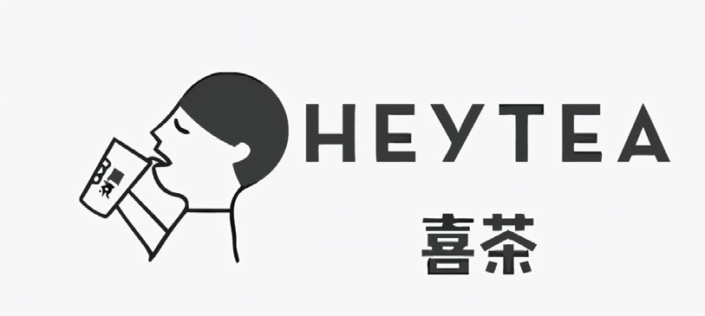
– | Suppose the profit of one HEYTEA branch per year is equal to the cost of opening a new branch.
• | If the owner does not borrow, the number of branches doubles every year.
– | In reality, HEYTEA grows faster by borrowing the cost to open a new branch.
• | This is one reason why finance is useful.
Year |  |  | Actual Stores |  | Financed by
  Stores—No debt
2012 |  |  | 1
  1
2013 |  |  | 4
  2
2014 |  |  | 9
  4
2015
  15
 |  | 8
 |  |  | 50 |  | IDG Capitals
  2016
 |  | 16
2017 |  |  | 80
  32
5




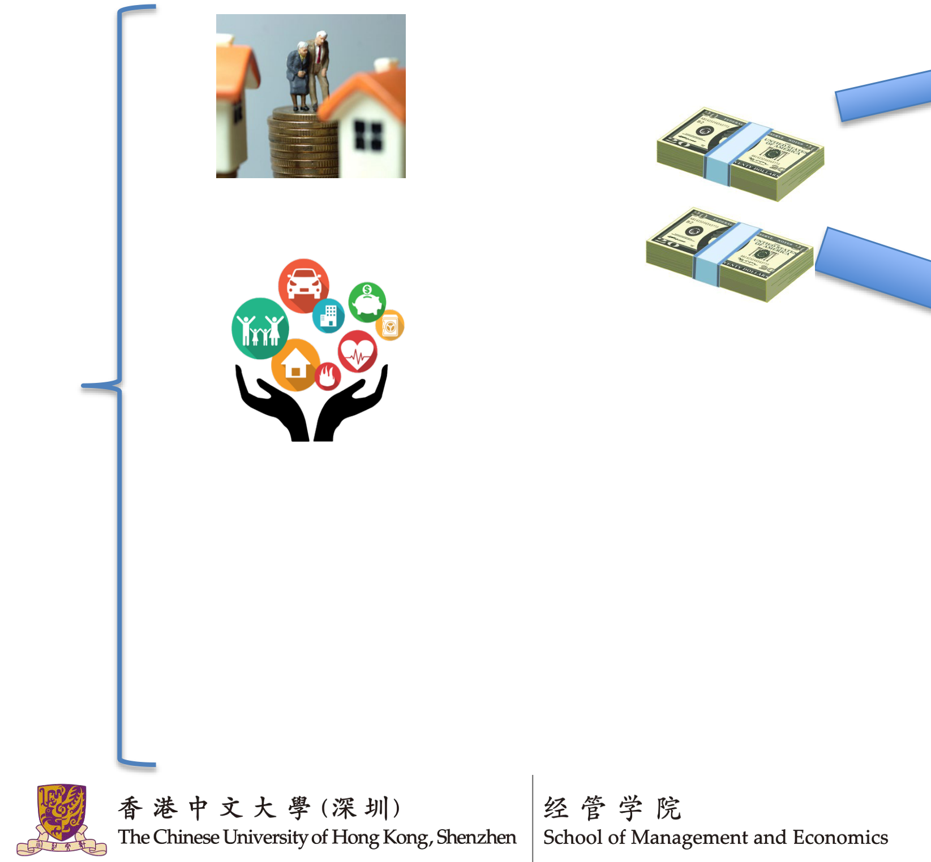





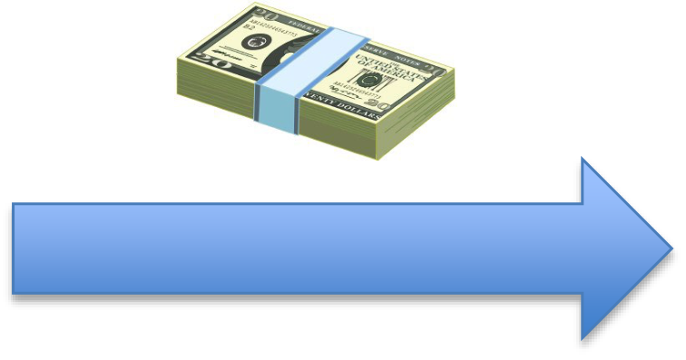

Who are the Investors? |  | Invest directly | Invest through managers | 6
Individuals |  | 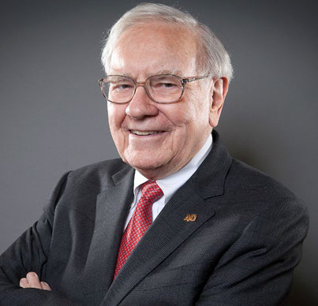 | Invest through managers | 6
Institutions | Pension Funds  Insurance |  | Invest through managers | 6
Institutions | Pension Funds  Insurance | Money Managers  • Mutual funds  • Hedge funds  • Venture capitals  • Private equities  Lecture 1: What is Finance | Invest through managers | 6
Others: Endowments, Sovereign Funds,  Firms… |  |  | Invest through managers | 6

Pension Funds (养老金)
Country | Fund | Assets (in billions)
United States | Federal Old-age and Survivors Insurance Trust Fund (Social Security) | $2,619
Australia | Australian National Superannuation Scheme | $2,568
Japan | Government Pension Investment Fund | $1,790
Norway | Government Pension Fund of Norway | $1,356
United States | Military Retirement Fund | $1,178
United States | Civil Service Retirement and Disability Fund | $1,003
United States | Thrift Savings Plan (TSP) | $822
Canada | Canada Pension Plan and CPP Investment Board (CPPIB) | $570
Netherlands | Stichting Pensioenfonds ABP (ABP) | $498
South Korea | National Pension Service (NPS) | $462
China | National Social Security Fund | $405
Model: Take monthly contribution from young people; pay back (more) when they get old.
Investment Goal: Meet future obligations
 | Lecture 1: What is Finance | 7

Global Money Management Firms
Rank | Company | Country of Origin | AUM (billion USD)
1 | BlackRock | United States | 9,090  7,600  4,240  3,960  3,600  3,131  3,006  2,672
2 | Vanguard Group | United States | 9,090  7,600  4,240  3,960  3,600  3,131  3,006  2,672
3 | Fidelity Investments | United States | 9,090  7,600  4,240  3,960  3,600  3,131  3,006  2,672
4 | UBS Group | Switzerland | 9,090  7,600  4,240  3,960  3,600  3,131  3,006  2,672
5 | State Street Global Advisors | United States | 9,090  7,600  4,240  3,960  3,600  3,131  3,006  2,672
6 | Morgan Stanley | United States | 9,090  7,600  4,240  3,960  3,600  3,131  3,006  2,672
7 | JPMorgan Chase | United States | 9,090  7,600  4,240  3,960  3,600  3,131  3,006  2,672
8 | Goldman Sachs | United States | 9,090  7,600  4,240  3,960  3,600  3,131  3,006  2,672
9 | Credit Agricole | France | 2,660
10 | Allianz Group | Germany | 2,364
, as of 2023 Model: Invest other people’s money and earn management fees, which is typically 0.1 to 1% of assets under management (AUM).
Investment Goal: Maximize AUM by outperforming competitors.
 | Lecture 1: What is Finance | 8

Chinese Money Management Firms
Rank | Company | AUM (trillion RMB)
1 | China Life Asset Management 国寿资管 | 5.37
2 | Ping An Asset Management 平安资管 | 5.03
3 | Taikang Insurance Group 泰康资管 | 3.40
4 | CMB Wealth Management 招银理财 | 2.55
5 | CIB Wealth Management 兴银理财 | 2.26
6 | China Southern Fund Management 南方基金管理 | 1.89
7 | China Asset Management 华夏资管 | 1.82
8 | E Funds Management 易方达 | 1.62
9 | China Taiping Insurance Group 太平资管 | 1.23
10 | CCB Principal Asset Management 建信基金管理 | 1.17
Source: ; 2023 Annual Reports
 | Lecture 1: What is Finance | 9

Agenda
•Investors and borrowers
•Does finance create value?
•Financial institutions
•About this course
 | Lecture 1: What is Finance | 10

Does Financial Industry Create Value?
•It seems the financial industry only transfers wealth but does not create wealth. Is this true?
•No! Financial industry creates value in many ways. Most important channels are:
1. | Allocating resources efficiently |  | 11
2. | Making deals happen |  | 11
Other channels: |  |  | 11
– | Providing liquidity (流动性), i.e., making it possible to trade whenever one wishes to |  | 11
– | Providing information |  | 11
– | Stabilizing the market and reducing risks |  | 11
 |  | Lecture 1: What is Finance | 11

Value Creation — 1. Allocating Resources Efficiently •Suppose there are two firms:
Firm A can turn $1 to $2 in a year
Firm B can turn $1 to $1.1 in a year
•If we have $100 to allocate to the two firms.
1.  2. | An economy with efficient financial industry will allocate all $100 to firm A. A year later the society has $200  An economy with inefficient financial industry may allocate $50 to each firm. A year later the society has $155
•Challenge: How do you identify which is firm A and which is firm B?
– | Key skill: Understand and be able to model the world. |  | 12
 |  | Lecture 1: What is Finance | 12


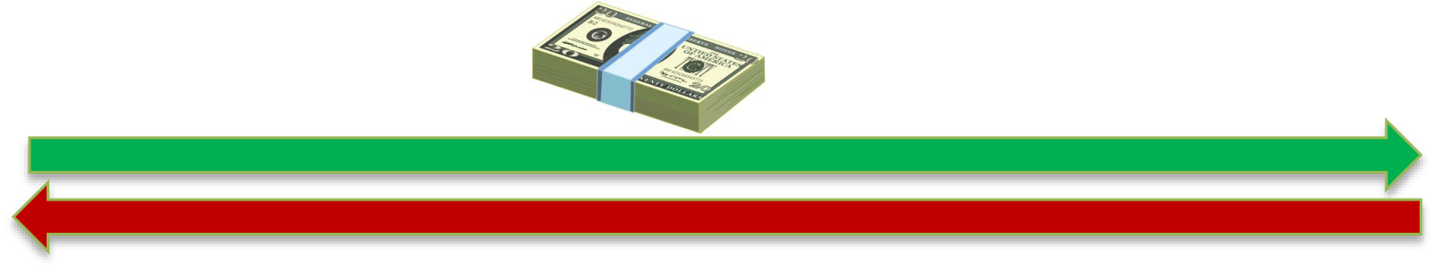







Value Creation — 2. Making Deals Happen (Promoting Growth) |  |  |  |  |  |  |  | 13
Investor who has money but does  not have profitable projects  Demands low return |  |  | 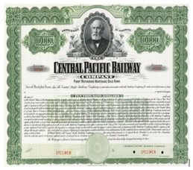 | Cash | Borrowers who need money to carry out profitable projects Earn high return |  |  | 13
 |  |  |  | Securities |  |  |  | 13
Challenges: |  | Reward (Dividends or interest) |  |  | Retained  earnings |  |  | 13
1. | Where do you find the investors and borrowers? |  |  |  |  |  |  | 13
2. | How do you know the borrower can repay and not run away with the money? |  |  |  |  |  |  | 13
3. | How do you convince the investor to invest? |  |  |  |  |  | Execute projects | 13
• Key skill: Maintain client relationship, have strong  interpersonal and communication skills.  Lecture 1: What is Finance |  |  |  |  |  |  | Execute projects | 13

What Securities do People Use?
Products in the financial markets are called securities.
•Equity (owning a portion of business)
– | Stock
•Simple Debt (payment amount is fixed)
–  – | Bond  Mortgage
•Derivatives (payment amount depends on future market prices)
– | Forward and Futures | Lecture 1: What is Finance | 14
– | Option | Lecture 1: What is Finance | 14
– | Swap | Lecture 1: What is Finance | 14
– | … | Lecture 1: What is Finance | 14

Agenda
•Investors and borrowers
•Does finance create value?
•Financial institutions
•About this course
 | Lecture 1: What is Finance | 15


Why do We Need the Middleman? |  |  |   10 Borrowers | 16
 |  |  |  | 16
100 Investors |  |  |  | 16
• | Reduce costs:  • Without a middleman, # of negotiations: 1000 With a middleman, # of negotiations: 110 |  | — More efficient! | 16
• | Specialization: the middleman provides useful service •Due diligence (collect info on borrowers)  •Risk sharing, diversification, liquidity  •Advisory  •Monitoring |  | — More efficient! | 16
 |  | Lecture 1: What is Finance | — More efficient! | 16


Who are the Middlemen?
Investors | Borrowers
Financial Industry
 | Lecture 1: What is Finance | 17

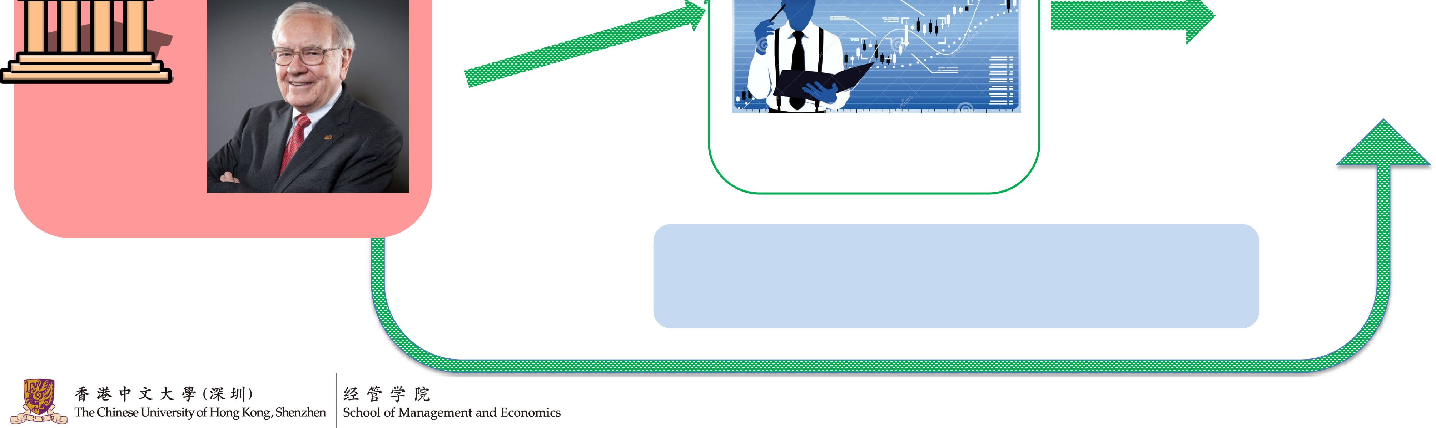


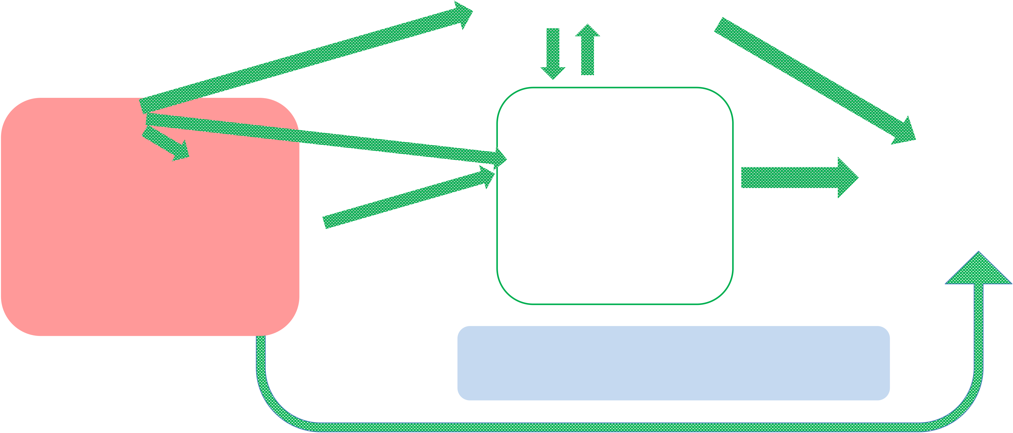
Who are the Middlemen? |   Commercial Banks
Individuals
Borrowers Institutions
Financial Market
Money Managers | Sell Side (Offer service) | Exchanges (e.g. Shenzhen Stock Exchange)  Investment banks (CICC (中金), Goldman Sachs) Brokerage firms (e.g. CMSC (招商证券))  Data vendors (e.g. Wind, Bloomberg)
Buy Side  (Have money) | Sell Side (Offer service)
Lecture 1: What is Finance
18

Jobs—Buy Side Institutions
Institutions | Tasks  • Manage cash flows to meet future obligations  • Manage risks of investments  • Identify good money managers to delegate the investments to  Good  • Light workload/working hours  • Have power so everyone respects you  Bad  • Pay is usually not as high as sell side institutions and limited  room to grow  • Hard to get in (may require connection) |  | 19
 |  | Lecture 1: What is Finance | 19

Jobs—Money Managers
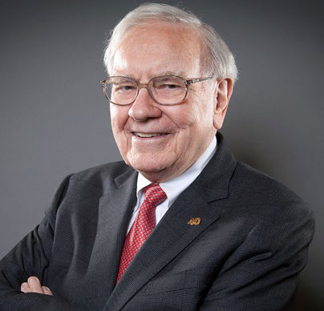  Money Managers | Tasks  • Generate superior investment performance  (Create value by allocating resource efficiently)  • Quantitative models  • Fundamental analysis  • Convince investors to put money into your fund (build trust)  Good  • Extremely high pay (if you perform well)  • Everyone around you is smart  Bad  • Can be stressful because pay is usually tied to performance  • Can be fired easily
 |  | Lecture 1: What is Finance | 20

Jobs—Banks
Commercial Banking  Tasks  • Deal with depositors  • Make loans to borrowers  • Sell investment products to investors to  earn incentive fees  • Manage risks  Good  • Stable (hard to get fired)  • Have many different posts so it is easy  to switch jobs  Bad  • Pay is usually not high  • Can be boring |  | Banks  Investment Banking  Tasks  • Primary market: help companies finance, or make  deals (IPO, merger & acquisition, liquidation)  • Trading: help meet the hedging needs  Good  • Very high pay (a large portion is bonus)  • Able to meet with important people  • Good exit options  Bad  • Extremely long working hours  • Sometimes toxic working environment
 | Lecture 1: What is Finance |  | 21

Jobs—Other Institutions  Brokerage Firms  • Help clients access the financial markets  • Technology  • Compliance  • Execution  • Provide market research    Brokers |  | Data Vendors  • Provide data to other participants  Exchanges  • Technology platform  • Answer to regulators
Financial Market |  |  | Market makers  • Maintain market liquidity Arbitrageurs  • Correct mispricing
 | Lecture 1: What is Finance |  |  | 22

Agenda
•Investors and borrowers
•Does finance create value?
•Financial institutions
•About this course
 | Lecture 1: What is Finance | 23

Plan for this Semester
•Basic tools (1-6)
–Time value of money, institutional knowledge
•Investors’ problems (7-13, 15-16)
– | Asset valuation (bond & stock) | Everyone will be an investor sometime in life!
– | Risk and Return | Everyone will be an investor sometime in life!
– | Financial Derivatives | Everyone will be an investor sometime in life!
– | Personal investment | Everyone will be an investor sometime in life!
•Midterm
•Corporates’ problems (17-23)
• | – | Capital structure | Useful if you ever plan to start your own business.
• | – | Cost of capital | Useful if you ever plan to start your own business.
• | – | Project valuation | Useful if you ever plan to start your own business.
• | AI and investment (25-26) |  | Useful if you ever plan to start your own business.
•Final
 | Lecture 1: What is Finance | 24

Course Objectives
•Knowledge: Understand what the financial industry does.
•Framework: Learn the framework of quantifying financial problems. –Quantifying: interpreting the problems using numbers and equations.
•Application: Learn how to make rational financial decisions.
– | Evaluate: should I buy this apartment/stock/product? |  |  | 25
– | Plan: to have X amount of money, I need to … |  |  | 25
– | Call out scams |  |  | 25
 |  | Lecture 1: What is Finance |  | 25

Setting the Correct Expectation
Social science, unlike natural science, cannot accurately describe the world.
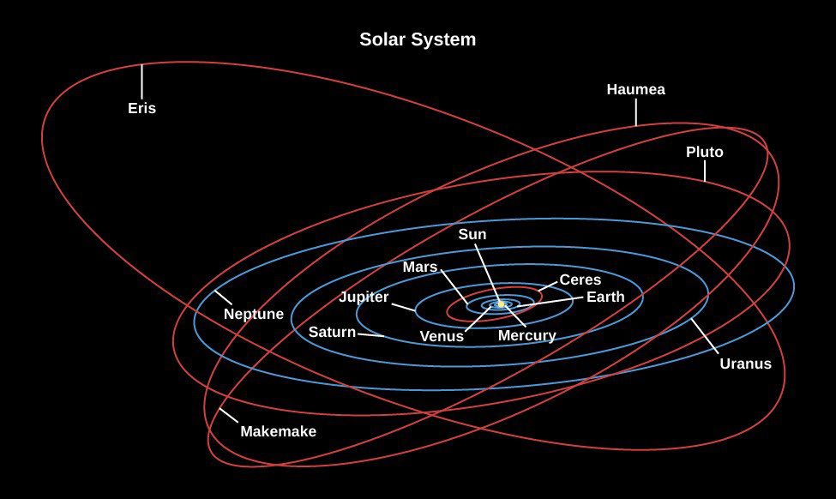 | 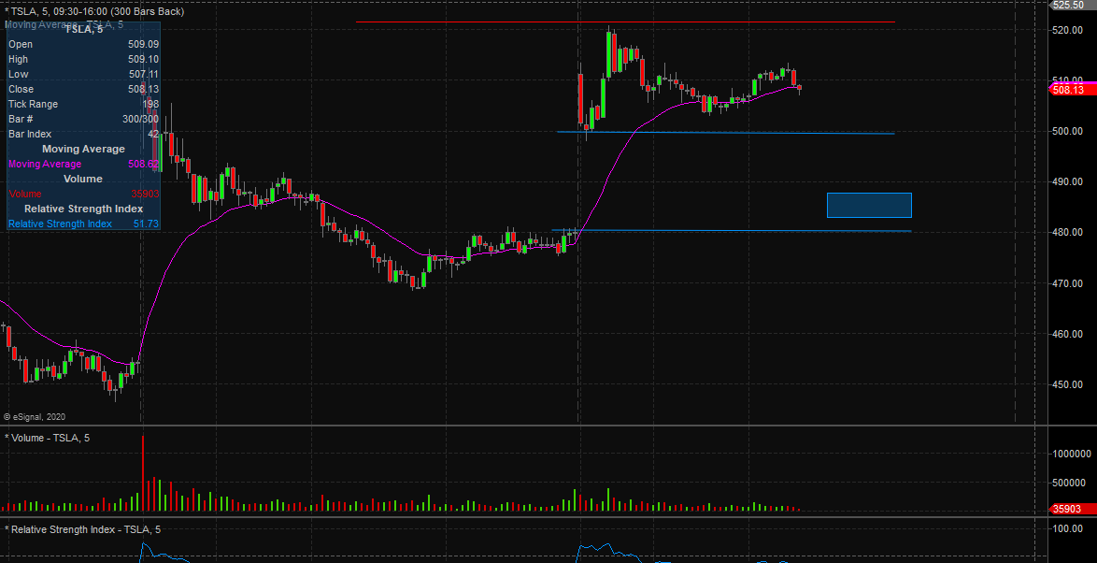
Then why do we learn this?
– | It is vastly better than a pure guess. |  | 26
– | You need to learn the primitive models first so that you can develop more advanced models in the future. |  | 26
 |  | Lecture 1: What is Finance | 26

Materials  •Textbooks |  | 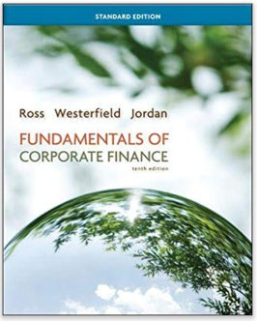
 | , by Stephen A. Ross, an
– | Not required
– | Strongly recommended for students without any prior knowledge of finance
•Regular calculator / financial calculator / scientific calculator
– | Regular calculator is sufficient. |  | 27
– | IF you are interested in CFA exam later, you can consider using Texas Instruments BA II Plus (including BA II Plus Professional) |  | 27
– | Calculators that you can use to program are NOT allowed on the midterm or the final. |  | 27
 |  | Lecture 1: What is Finance | 27

Course Logistics •Sections |  |  |  | You can make up a missed class by attending a different section. Send email to TA when you do this.
 |  | T/Th 6:00 PM  Xiyue Li  TxC 101
  M/W 8:30 AM Jaemin Lee
  TxC 202
 |  |  |  |  | 28
•Grading |  | Outcome based, consistent across all sections |  |  | 28
– | 5% | Participation (you get 0.25% each time) |  |  | 28
– | 15% | Homework (5% weekly online MC quizzes, 10% problem sets) |  |  | 28
– | 15% | Group project |  |  | 28
– | 30% | Midterm |  |  | 28
– | 35% | Final |  |  | 28
 |  |  | Lecture 1: What is Finance |  | 28

Group Project
•15% of your grade
•Goal: apply theories to evaluate an investment opportunity•Format: an 8-15 pages (including tables and graphs) report
•Logistics:
– | Groups of 4-5 students. Please form groups before 2026-10-31. |  | 29
– | Due date: 2026-12-13 11:59PM (may change based on the schedule) |  | 29
 |  | Lecture 1: What is Finance | 29

Office Hour
•It is important that you figure out any question asap!
 | Tue | Wed | Fri
  Mon
 | Xiyue Li  5:00-6:00PM TxD 808 | Jaemin Lee 1:00-2:00PM TxD 805 | KU Zhuo (TA) 2:00-3:00PM  TxD 8th Floor
  Shirley Wu (TA) 1:00-2:00PM
  TxD 8th Floor
  Cubicle 11

USTF — Library
L103
Peixuan Sun
10:30-11:30AM
Fucheng Ma
1:00-2:00PM
Kailai Jiang
2:00-3:00PM

 | Lecture 1: What is Finance | 31

Summary
•What is finance?
– | The study of how to make money flow efficiently from investors to borrowers and all other questions related to this process.
•Who are the investors and borrowers?
–  – | Investors: individuals and institutions  Borrowers: government, corporate, individual
•What value does the financial industry create?
–  – | Allocate resources efficiently  Make deals happen to promote growth
•What does the industry consist of?
– | Commercial banks
– | Buy side institutions and money managers
– | Brokers, investment banks, data vendors, exchanges, and many others
 |  | Lecture 1: What is Finance

Next Lecture—What is a Firm?
•Organizational Forms of a Firm
–Sole proprietorship
–Partnership
–Limited liability company (LLC)
–Corporation
•Organization Structure of a Corporation
•Agency Problems
 | Lecture 1: What is Finance | 33

